

# 7 Night Fly In Safari

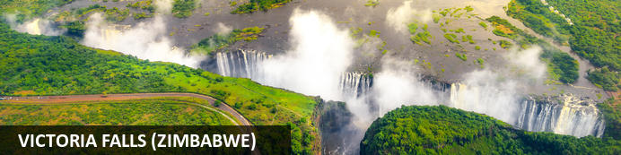

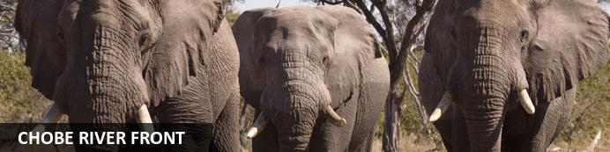

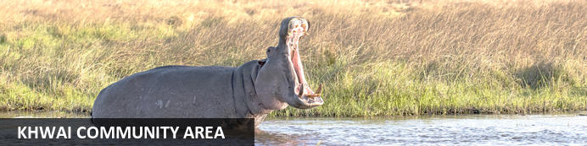

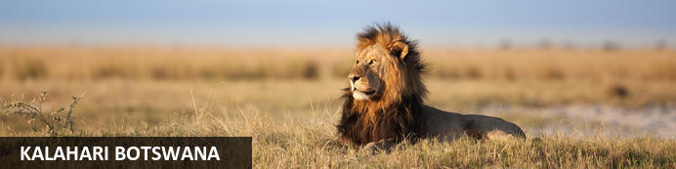

# 7 Night Fly In Safari

*Victoria Falls (Zimbabwe) - Chobe River Front - Khwai Community Area - Kalahari Botswana*  
*8 Days / 7 Nights*  
*0 Persons*  
*Date of Issue: 15 November 2023*

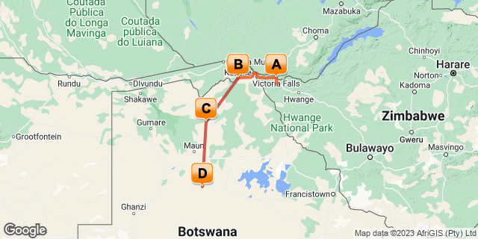

## Introduction

This exciting fly-in multi lodge safari offers both comfort and adventure in some of Botswana's prime wildlife areas. This activity packed safari begins in Victoria Falls, Zimbabwe; forming an adventurous route through parks in Botswana allowing you to discover the diversity that Botswana has to offer. Accommodation throughout your journey with us includes stunning immersive lodges.

|  |  |  |
| --- | --- | --- |
| **Accommodation** | **Destination** | **Duration** |
| Pioneers Victoria Falls | Victoria Falls (Zimbabwe) | **1 Night** |
| Chobe Elephant Camp | Chobe River Front | **2 Nights** |
| Sango Safari Camp | Khwai Community Area | **2 Nights** |
| Deception Valley Lodge | Kalahari Botswana | **2 Nights** |

## Included

* 2 nights Deception Valley Private Reserve
* Explore a private game reserve in the Kalahari
* 2 nights Khwai Guest House
* Explore Moremi Game Reserve and Khwai concession
* 2 nights Chobe Elephant Camp
* Explore Chobe National Park
* Light air-craft transfers between lodges

## Day 1: Pioneers Victoria Falls, Victoria Falls (Zimbabwe)

### Day Itinerary

Your safari starts with a pick up from Victoria Falls Airport where you will be transferred to your first lodge. You will have the afternoon at leisure and have an opportunity to enjoy the various activities offered at the thunderous falls; zip lining, white water rafting, bungee jumping, helicopter scenic and so much more. Dinner this evening will be at your own expense.

### Victoria Falls (Zimbabwe)

Victoria Falls is one of the world’s most impressive waterfalls. It is set on the magnificent Zambezi River which creates the border between Zambia and Zimbabwe. These spectacular falls can be easily visited and viewed from the Zimbabwean side. Considered to be the world’s widest waterfalls, Victoria Falls measures an impressive 1708 metres in width. The small town of Victoria Falls, which lies adjacent to the waterfalls, serves as a great base from which to explore the many attractions this area of Zimbabwe has to offer. The surrounding area provides a wide range of adrenalin-filled activities for adventure lovers. Visitors can look forward to an array of wonderful activities including: scenic flights, micro lighting, white water rafting, bungee jumping, kayaking, and once-in-a-lifetime expeditions into the incredible Chobe National Park.

### Overnight: Pioneers Victoria Falls

Set in lush gardens with beautifully manicured lawns, this fifty room lodge is a great option for those who value comfort and elegance. The rooms are spacious and tastefully decorated in a classic style, and each has a clear and open view of the garden.

The heart of “Pioneers” Lodge is the centrally located main area. The layout and classic décor here is extremely welcoming with a serene and stylish lounge which is airy and comfortable, and the rich inside dining room is certainly nostalgic and inviting. The guests also have the option of relaxing and dining on the spacious and expansive terrace, overlooking lush gardens. There is a large saloon style bar area which serves a variety of cold and hot beverages, including local craft beer made from our very own Zambezi water. For the modern traveller, Wi-Fi is important and this is readily available throughout the lodge. Well placed in the lush gardens are two swimming pools for the guests to use at their leisure. In addition to these, a day spa, TV Room and a meetings room are also available on the property.

Pioneers is a family friendly property

### Included

* Airport pick up
* 1 night accommodation - bed and breakfast

## Day 2-4: Chobe Elephant Camp, Chobe River Front

### Day Itinerary

Your safari adventure into Botswana starts today as you make way by road transfer  towards a rustic camp at the edge of Chobe National Park, where you will stay 2 nights to explore the northern reaches of the park. Time is spent in northern Chobe, a park which is incredibly rich in game due to the Chobe River providing water all year round. Large herds of elephant and buffalo are frequently seen. Due to the high density of herbivores in this area many predators, such as lions and leopards, can be found. While staying at Chobe Elephant Camp you will do a game drive and boat cruise within the Chobe National Park where you immerse yourself into this incredible area from both land and water

### Chobe River Front

The Chobe River forms the northern boundary of the Chobe National Park which is renowned for its diverse and abundant game viewing opportunities. This section of the park is best known for its dense concentration of wildlife, including elephant and hippo populations, but the waters attract all manner of game including large herds of buffalo and the lions that prey on them - a visit to the Chobe River Front guarantees close encounters with an array of African wildlife. Visitors can look forward to a range of exciting activities such as 4WD along the banks; motorboat cruises; and rare birdlife spotting. For a unique, luxury safari experience, hire a houseboat.

### Overnight: Chobe Elephant Camp

Situated on a rocky ridge, overlooking the spectacular Chobe River Floodplains, Chobe Elephant Camp offers guests ample opportunities to explore the wild surroundings while providing a stunning viewpoint onto one of Botswana’s prime destinations.

Entirely built out of sandbags from the red Kalahari sands that dominate the northern part of Botswana, this eco-friendly lodge presents an original design reminiscent of traditional African farmsteads and can accommodate up to 36 guests in twelve chalets. All rooms are en-suite with both indoor and outdoor showers and have private verandas to fully enjoy the views and surroundings.

The lodge also boasts a large open-plan main area featuring a cosy arrangement of couches, bar, dining area and reading corner, along with a swimming pool with viewing deck onto a private water hole. With a variety of activities that include viewing the regions spectacular wildlife from open safari vehicles, by canoe along the Chobe floodplain or by boat on the Chobe River, along with excursions to the nearby village to get introduced to the local culture, this newly developed lodge offers a wide range of experiences to its guests.

### Activities

|  |
| --- |
| Chobe National Park Game Viewing |
| Boat cruise along Chobe River |

#### Chobe National Park Game Viewing

The Chobe National Park in Botswana is only a 1¾-hour drive from Victoria Falls. It is one of the greatest game reserves in southern Africa, famous for its elephant numbers. The Chobe River and Caprivi flood plains provide a haven for huge herds of buffalo, elephant, zebra, wildebeest and impala which are followed closely by lions, hyenas and leopards and the bird life is exceptional.

### Included

* Road transfer from Victoria Falls to Kasane
* 2 nights Chobe Elephant Camp
* Camp activities
* Full-board meals and local drinks

## Day 4-6: Sango Safari Camp, Khwai Community Area

### Day Itinerary

On day 4 your journey leads you to the Khwai River area, on the border of the Moremi Game Reserve - one of the best wilderness areas of Botswana with very high concentrations of game. You will board a light aircraft to Khwai area. The next two days will be spent searching for the wide variety of wildlife and birds that this area is renowned for, while absorbing the sounds and beauty of this region. Enjoy game drives in the early morning as the sun rises and late afternoon as the sun sets. You will also have an opportunity to do a mokoro excursion into a community-managed concession area. Your guide will take you on a scenic drive to the mokoro station where you will meet your mokoro poler/guide, who will share with you hidden secrets of this water system. You also have an opportunity to do a village tour, for an appreciation of the local culture of those living in this wildlife area.

### Khwai Community Area

The Khwai area of the Okavango lies along the northern boundary of the Moremi Game Reserve. Khwai Community Area has unfenced boundaries allowing wildlife to move freely between the woodlands in the wet season when water is plentiful and back to permanent rivers and lagoons in the dry season. The Khwai area offers the same wildlife experience as the Moremi Game Reserve with the added advantage of being a private concession, which means the ability to do walking safaris and night drives. Don't miss the opportunity to soak up beautiful views of the scenic landscape and spot an array of wildlife.

### Overnight: Sango Safari Camp

The Sango Safari Camp lies comfortably on the edge of the Khwai River in the Okavango Delta and borders the world-renowned Moremi Game Reserve. Sango is located in a prime position; offering the best of both land and water safaris. Wildlife roams freely throughout the Khwai Concession and the Moremi Game Reserve – the Khwai River forms a natural border between these wildlife rich regions.

Guests can enjoy traditional Mokoro trips in dug-out canoes, night game drives and even adventurous bush walks. There is also a cultural village nearby for those interested in local customs and cultures.

### Activities

|  |
| --- |
| Game drives |
| Khwai Mokoro Excursions |

### Included

* Light aircraft transfer to Khwai
* 2 nights Sango Safari Camp
* Camp activities
* Full-board meals and local drinks

## Day 6-8: Deception Valley Lodge, Kalahari Botswana

### Day Itinerary

After your last morning in Khwai you will be linked to board a light aircraft that will fly you toward the Kalahari region where you will spend two nights at Deception Valley Lodge. You will fly to the Deception Valley Private Reserve located along the northern border of the Central Kalahari Game Reserve. Time will be spent duration of your stay enjoying game drives and participating in a nature walk led by a local San tracker. They will share their intricate bush knowledge and give you an insight into their unique and intriguing culture. You will also do game drives explore the area, home to a fascinating variety of desert specialised wildlife such as oryx and predators including lion, hyena and cheetah. Savour the vast open spaces, clear night skies and uninterrupted beauty.

### Kalahari Botswana

Encompassing the vast majority of Botswana territory, the sprawling wilderness of the semi-arid Kalahari Desert is characterised by endless open plains, shimmering salt pans, picturesque orange sands and relics of ancient riverbeds. In the heart of the country lies the world's second-largest game reserve, the Central Kalahari Game Reserve, its magnificent expanse surpassing the size of the entire country of Belgium. The region offers some of the best wildlife viewings in Africa and is home to abundant roaming wildlife, including rhinos, black-maned lions, and desert-adapted elephants. Keen birdwatchers can spot the secretary bird, pale chanting goshawk, ostrich, black-breasted snake eagle and other species. For the culturally curious, an encounter with the San, the indigenous people who have resided in and around the area for thousands of years, is not to be missed.

### Overnight: Deception Valley Lodge

Deception Valley Lodge an oasis in the Kalahari of Botswana, a luxury lodge close to the famous Okavango Delta. Experience the Kalahari with Bushmen at hand, to share their knowledge, while you can relax in total luxury at this unique destination.

Combining your visit of the Kalahari with the well-known area of the Okavango Delta to the north and the famous Victoria Falls would ensure that your safari to Africa would remain a treasured memory.

What makes Deception Valley Lodge unique is the rare opportunity to meet and explore this remarkable environment with bushman Guides of the San peoples, one of the oldest cultures in Africa. Experience a tour with real Bushmen. Exploring the bush on foot, while your guide will teach you of the hunting and survival skills, the culture and crafts of the San people, who over the centuries have adapted their lives to survive in the most inhospitable environment of them all.

### Activities

|  |
| --- |
| Game drives Deception Valley Private Reserve |
| San bushman walk |

### Included

* Light aircraft transfer to Deception Valley Private Reserve
* 2 nights Deception Valley Lodge
* Camp activities
* Full-board meals and local drinks

## Day 8: End of Itinerary

### Day Itinerary

Your 7 night journey ends today as you take in the last bit of sights and sounds of the Botswana bush. You will be flown to Maun International Airport, the gateway to the Okavango and bid farewell to you timeless adventure!

### Included

* Light aircraft transfer to Maun

# Transport

## Flight Information

|  |  |  |  |  |  |  |  |  |
| --- | --- | --- | --- | --- | --- | --- | --- | --- |
| **Date** | **Flight** | **Airline** | **Departure Airport** | **Time** | **Arrival Airport** | **Time** | **Class** | **Ref** |
|  | Scheduled |  | Chobe Elephant Camp |  | Sango Safari Camp |  |  |  |
|  | Scheduled |  | Sango Safari Camp |  | Deception Valley Lodge |  |  |  |
|  | Scheduled |  | Deception Valley Lodge |  | Maun International Airport [MUB] |  |  |  |

## Transfers

|  |  |  |  |  |  |
| --- | --- | --- | --- | --- | --- |
| **Date** | **Company** | **Pick Up** | **Drop Off** | **Time** | **Vehicle** |
|  |  | Victoria Falls International Airport [VFA] | Pioneers Victoria Falls |  | Transfer |
|  |  | Pioneers Victoria Falls | Chobe Elephant Camp |  | Transfer |

### Urgent Contact Numbers

|  |  |  |  |
| --- | --- | --- | --- |
| **Company Name** | **Telephone** | **Email Address** | **Contact Person** |
| Bush Ways | +267 686 3685 | marketing@bushways.com | Vihemba Vasco |

### Service Provider Directory

|  |  |  |  |
| --- | --- | --- | --- |
| **Service Provider** | **Ref. Number** | **Telephone** | **Address** |
| Chobe Elephant Camp |  | +267 686 3685 |  |
| Deception Valley Lodge |  | +267 686 3685 | Plot K1999  Matshwane Industrial |
| Pioneers Victoria Falls |  | +263 78 724 7838 | Mahogany Rd Victoria Falls 00000 |
| Sango Safari Camp |  | +267 686 3763 | Private Bag 342  Maun - Botswana |